My SQL Worksheet-1
(DDL – Database Related commands)
1. | If a database "Employee" exists, which MySql command helps you to start working in that database?
 | Use Employee;
2. | Write MySql command will be used to open an already existing database "LIBRARY".
 | Use Library;
3. | Write MySql command to open an existing database.
 | Use databasename;
4. | What does SQL stand for? What is MySQL?
SQL Stands for structured query language.
Mysql is an open source RDBMS (Relational Database Management System)

5. | Write two examples of DBMS software.
 | SQL Server, My SQL, Oracle, Ingres, Postgres
6. | Sharmila wants to make the database named ‘COMPANY’ active. Write MySQL commands for it.
 | Use Company;
7. | What is MySQL ?
 | Mysql is an open source RDBMS (Relational Database Management System)
8. | What is the relationship between SQL and MySQL ?
 | SQL is a language to give commands in MySQL or any other RDBMS software.
9. | Mention any two example of common Database Management System.
 | SQL Server, Ingres, Postgres, MySQL
10. | Suggest Archana suitable command for the following purpose:  - To display the list of the database already existing in MySQL.  - To use the database named City.  - To remove the pre-existing database named Clients.
i. Show Databases;
ii. Use City;
iii. Drop database clients;

11. | Write the command to display the name of the active database.
 | Select Database();
12. | Write the command to create a new database “School”
 | Create database school;

Informatics Practices
My SQL Worksheet-2
(DDL – Table Related commands excluding Alter table)
1. | Write an SQL query to create the table 'Menu' with the following structure:  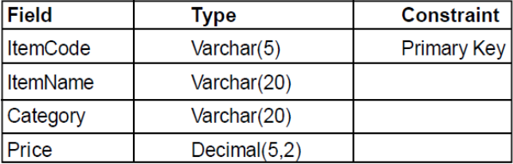
Create table Menu(
ItemCode varchar(5) Primary key,
Itemname varchar(20),
Category Varchar(20),
Price Decimal(5,2));
2. | Can a table have multiple primary keys? Can it have multiple foreign keys?
No, a table cannot have multiple primary keys. There can only be one primary key.
Yes, a table can a multiple foreign keys.

3. | In a Student table, out of Roll Number, Name, Address which column can be set as Primary key and why?
 | RollNumber can be set as Primary Key as two students cannot have a same roll number.
4. | Ms. Mirana wants to remove the entire content of a table "BACKUP" alongwith its structure to release the storage space. What MySql statement should she use ?
 | Drop Table Backup;
5. | Write MySql command to create the Table STOCK including its Constraints.  Table STOCK :  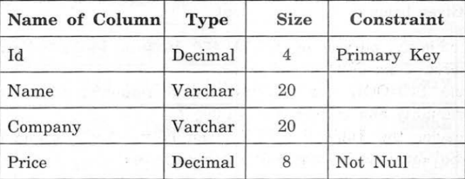
Create table Stock(
Id Decimal(4) Primary Key,
Name Varchar(20),
Company Varchar(20),
Price Decimal(8) Not Null);
6. | Write one similarity and one difference between CHAR and VARCHAR data types.
Similarity:
Both char and varchar can store alphabets as well as numbers. Both can store same type of values.

Difference:
Char is a fixed length character datatype whereas varchar is a variable length character datatype.

7. | Saumya had previously created a table named ‘Product’ in a database using MySQL. Later on she forgot the table structure. Suggest her suitable MySQL command through which she can check the structure of the already created table.
 | Describe Product;
8. | Roli wants to list the names of all the tables in her database named ‘Gadgets’. Which command (s) she should use to get the desired result.
Use Gadgets;
Show tables;
9. | Name the SQL commands used to :  (i) Physically delete a table from the database.  (ii) Display the structure of a table.
- Drop table tablenae;
- Describe tablename;
10. | Write one similarity and one difference between UNIQUE and PRIMARY KEY constraints.
Similarity:
Both Unique and primary key restricts duplicate values in the field.
Difference:
Unique allows null values whereas Primary doesnot allow null values to be inserted in the field.
11. | An attribute A of datatype varchar(20) has the value “Amit” . The attribute B of datatype char(20) has value ”Karanita” . How many characters are occupied in attribute A ? How many characters are occupied in attribute B?
A will occupy 4 character space.
B will occupy 20 character space.
12. | Mrs. Sharma is the classteacher of Class ‘XII A’ She wants to create a table ‘Student’  to store details of her class.  i) Which of the following can be the attributes of Student table?  a) RollNo b) “Amit” c) Name d) 25  ii) Name the Primary key of the table ‘Student’. State reason for choosing it.
- RollNo and Name can be the attributes of student table.
- RollNo can become the primary key of the student table as two students cannot have a same roll number.
13. | Write SQL query to create a table ‘Player’ with the following structure:  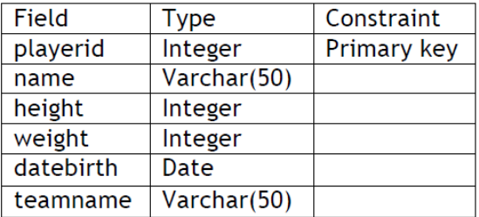
Create table Player(
Playerid integer primary key,
Name varchar(50),
Height integer,
Weight integer,
Datebirth date,
Teamname varchar(50));
14. | Anita has created the following table with the name ‘Order’.  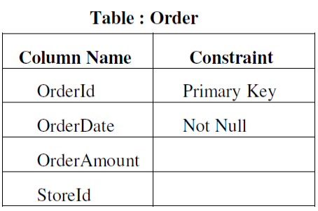  One of the rows inserted is as follows :  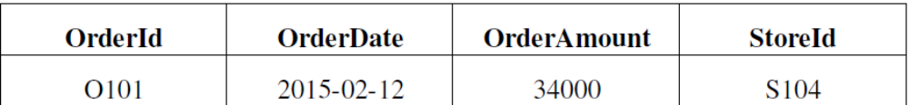  (i) What is the data type of columns OrderId and OrderDate in the table Order ?  (ii) Anita is now trying to insert the following row :  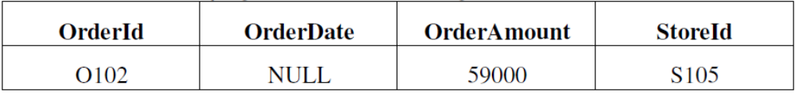  Will she be able to successfully insert it ? Give reason.
- The datatype for orderID field can be either char or varchar
The datatype for orderDate is date
- She will not be able to insert the above record as she is inserting a null value in the orderdate field and the orderdate field have a not null constraint which cannot accept null values.
15. | Write SQL query to create a table ‘Event’ with the following structure :
  Field | Type | Constraint
  EventId | Varchar(5) | PRIMARY KEY
  EventName | Varchar(30) | NOT NULL
  Location | Varchar(50)
  ClientID | Integer
  EventDate | Date
Create table Event(
EventID varchar(5) Primary Key,
EventName varchar(30) not null,
Location varchar(50),
CleintID Integer,
EventDate date);
16. | Observe the given table carefully and answer the following questions:  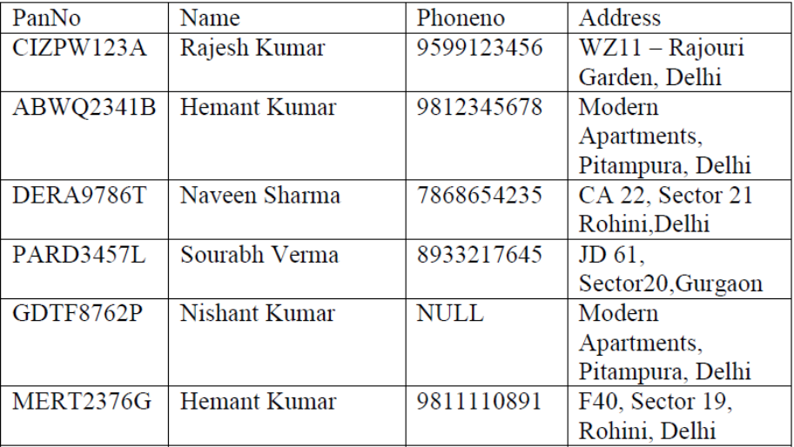  i. Name the column that might have a Primary Key constraint. Justify your answer.  ii. Name the column that might have a Unique constraint. Justify your answer.
- PanNo might have a Primary Key constraint as two person cannot have a same Pan Number.
- PhoneNo might have a unique constraint as two person will be having different mobile numbers.
17. | “ABC” Event Management Company requires data of events that are to be organized. Write SQL query to create a table ‘Event’ with the following structure :  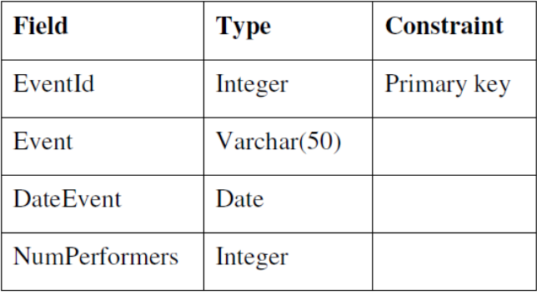
Create table Event(
EventID Integer Primary Key,
Event Varchar(50),
DateEvent Date,
NumPerformers Integer);
18. | suggest her suitable command for the following purpose:  - To display the list of the database already existing in MySQL.  - To use the database named City.  - To remove the pre-existing database named Clients.  - To remove all the records of the table named “Club” at one go along with its structure permanently.
- Show databases;
- Use City;
- Drop database Clients;
- Drop table Club;
19. | While creating a table named “Employee”, Mr. Rishi got confused as which data type he should chose for the column “EName” out of char and varchar. Help him in choosing the right data type to store employee name. Give valid justification for the same.
 | EName field can have a varchar as a datatype as two employees will not be having a same length of their names.

Informatics Practices
My SQL Worksheet-3
(DDL – Table Related commands)
1. | Sahil created a table in Mysql. Later on he found that there should have been another column in the table. Which command should he use to add another column to the table?
 | Alter table tablename add fieldname datatype(size);
2. | While creating a table 'Customer' Simrita forgot to set the primary key for the table. Give the statement which she should write now to set the column 'CustiD' as the primary key of the table?
 | Alter table customer add primary key(custid);
3. | Kuhu has already created a table ‘Hospital’ as shown below:  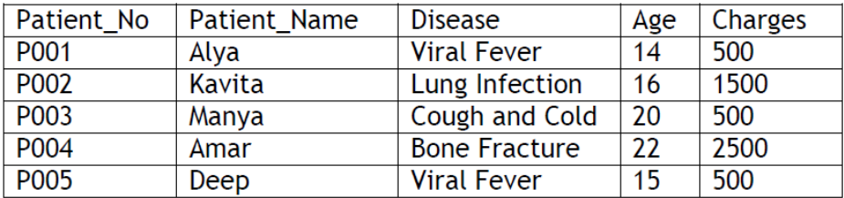  Now she wants to add a new column ‘Address’ to the above given table. Suggest suitable MySQL command for the same.
 | Alter table hospital add address varchar(30);
4. | Write SQL command to remove column named ‘Hobbies’ from a table named ‘Student’.
 | Alter table student drop hobbies;
5. | While creating the table Student last week, Ms. Sharma forgot to include the column Game_Played. Now write a command to insert the Game_Played column with VARCHAR data type and 30 size into the Student table?
 | Alter table student add game_played varchar(30);
6. | Kunal created the following table with the name ‘Friends’ :  Table : Friends  Now, Kunal wants to delete the ‘Hobbies’ column. Write the MySQL statement
  FriendCode | Name | Hobbies
  F101 | Bijoy | Swimming
  F102 | Abhinav | Reading books
  F103 | Jyotsna | Dancing
 | Alter table friends drop hobbies;
7. | Rashi wants to add another column ‘Hobbies’ with datatype and size as VARCHAR(50) in the already existing table ‘Student’. She has written the following statement. However it has errors. Rewrite the correct statement.  MODIFY TABLE Student Hobbies VARCHAR;
 | Alter table student add hobbies varchar(50);
8. | Ms. Shalini has just created a table named “Employee” containing columns  Ename, Department, Salary.  After creating the table, she realized that she has forgotten to add a primary key column in the table. Help her in writing SQL command to add a primary key column empid. Also state the importance of Primary key in a table.
 | Alter table employee add primary key(empid);
9. | While creating a table 'Customer' Simrita wrongly added a primary key constraint to the field “CUSTNAME”. Now she wants to remove the primary key constraint from the custname field. Help her in writing the correct command.
 | Alter table customer ass primary key(custname);
10. | Mr. Akshat have added a not null constraint to the “name” field in “employees” table. But now he wants to remove that not null constraint. Write the command to delete the not null constraint from name field.
 | Alter table employee modify name varchar(30) null;

Informatics Practices
My SQL Worksheet-4
(DML – INSERT INTO commands)
1. | Rama is not able to change a value in a column to NULL. What constraint did she specify when she created the table?
 | Not Null, Primary Key
2. | Consider the table RESULT given below. 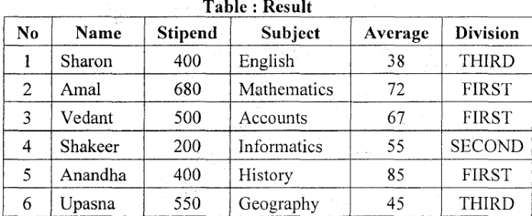  Write command to insert a new row  6, "Mohan", 500, "English", 73, "Second"
 | Insert into Result values(6, "Mohan", 500, "English", 73, "Second");
3. | Consider the Table SHOPPE given below.  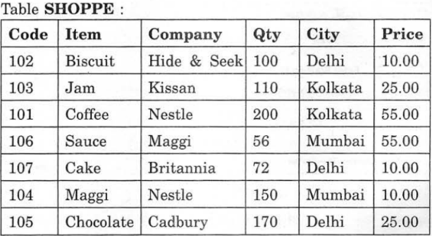  To insert a new row in the table Shoppe  '110', 'Pizza' , 'Papa Jones', 120, "Kolkata", 50.0
 | Insert into Result values('110', 'Pizza' , 'Papa Jones', 120, "Kolkata", 50.0);
4. | How is NULL value different from 0 (Zero) value?
 | Null means no value whereas 0 is a value.
5. | Consider the following table named "GYM"  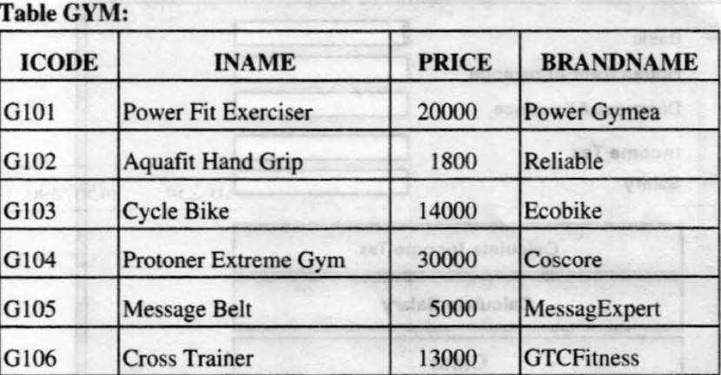  Add a new row for a new item in GYM with the details: "G107", "Vibro exerciser” ,21000, “GTCFitness"
 | Insert into Result values("G107", "Vibro exerciser” ,21000, “GTCFitness");
6. | What is meant by NULL value in MySQL?
 | Null means no value
7. | Rewrite the following SQL statement after correcting error(s). Underline the corrections made.  INSERT IN STUDENT(RNO,MARKS) VALUE (5,78.5);
 | INSERT INTO STUDENT(RNO,MARKS) VALUES (5,78.5);
8. | Rewrite the following SQL statement after correcting error(s). Underline the corrections made.  INSERT IN EMP(EMPNO, SALES) VALUE (100, 20078.50);
 | INSERT INTO EMP(EMPNO, SALES) VALUES(100, 20078.50);
9. | Charvi is inserting “Sharma” in the “LastName” column of the “Emp” table but an error is being displayed. Write the correct SQL statement.  INSERT INTO Emp(‘Sharma’)VALUES(LastName) ;
 | INSERT INTO Emp(LastName) VALUES(‘Sharma’) ;
10. | Anita has created the following table with the name ‘Order’.  One of the rows inserted is as follows :  (i) What is the data type of columns OrderId and OrderDate in the table Order ?  (ii) Anita is now trying to insert the following row :  Will she be able to successfully insert it ? Give reason.
- The datatype for orderID field can be either char or varchar
The datatype for orderDate is date
- She will not be able to insert the above record as she is inserting a null value in the orderdate field and the orderdate field have a not null constraint which cannot accept null values.

11. | In today’s digitized world with a need to store data electronically, it is very important to store the data in the databases. SQL is used to interact with the Database Management System.  Classify the following commands according to their type :(DDL/DML)  i. INSERT INTO ii. ALTER TABLE
 | i. DML ii. DDL
12. | Is NULL and 0(zero) same? Jusify your answer.
No null is not same as 0. Null means no value. 0 is a value.
Any numerical calculation on null will give null
Any numerical calculation on 0 will do the actual calculation.

13. | Write the full forms of the following:  i. DDL ii. DML
i. Data Definition Language
ii. Data Manipulation Language

Informatics Practices
My SQL Worksheet-5
(DML – UPDATE and DELETE commands)
1. | What is the purpose of DROP TABLE command in SOL? How is it different from DELETE command?
 | Drop table deletes the table along with the structure. Delete deletes the records.
2. | In a database there are two tables "Product" as shown below :  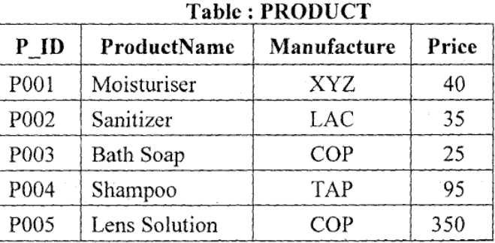  Write the command To increase the Price of all the Products by 20.
 | Update Product set price=price + 20;
3. | Write the UPDATE command to change “Sharma” to “Singh” in the “LastName” column in the Employee table.
 | Update Employee set Lastname=”Singh” where lastname=”Sharma”;
4. | What is the use of UPDATE statement in SQL ? How is it different from ALTER statement?
Update command updates the records.
Alter command modifies the structure of the table.

5. | Consider the following table named "GYM"  Write command To change the Brandname to "Fit Trend India" of the item, whose ICODE as "G101 ".
 | Update Gym set brandname=”Fit Trend India” where Icode=”G101”;
6. | Write the UPDATE statement in MySQL to increase commission by 100.00 in the ‘‘Commission’’ column in the ‘Emp’ table.
 | Update emp set commission=commission + 100.00;
7. | Write two examples of DML commands of SQL.
 | Insert, Update, delete, select
8. | In a database there are two tables ‘CD’ and ‘TYPE’ as shown below :  Write SQL statement to change the name of Singer ‘‘Sonvi Kumar’’ to ‘‘Sonvi Mehra’’ in all the places wherever it occurs in CD table.
  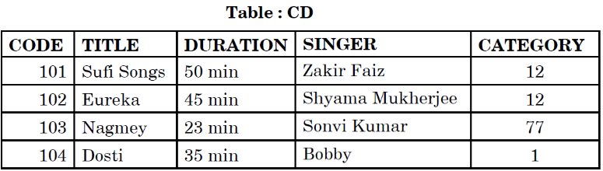 | 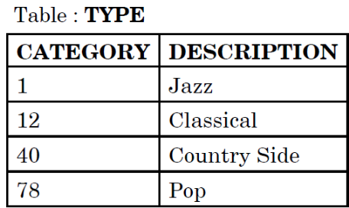
 | Update CD set singer=”Sonvi Mehra” where singer=”Sonvi Kumar”;
9. | Consider the following table named “GARMENT”.  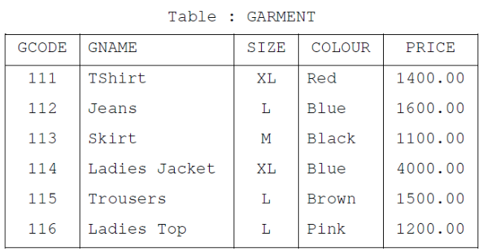  - Write command To change the colour of garment with code as 116 to “Orange”.  - Write command to increase the price of all XL garments by 10%  - Write command to delete the record with GCode “116”
- Update Garment set colour=”Orange” where Gcode=116;
- Update Garment set price=price+price*10/100 where size=”XL”;
- Delete from garment where gcode=116;
10. | In a Database, there are two tables given below :  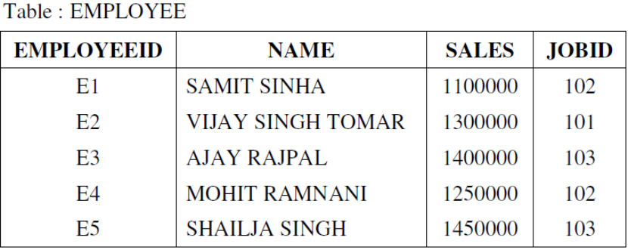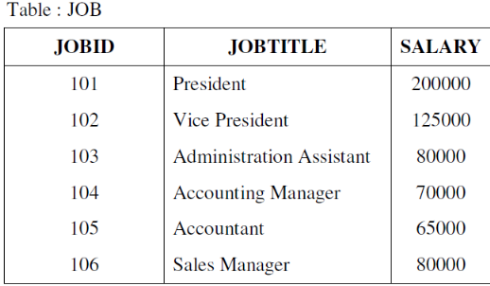  Write SQL command to change the JOBID to 104 of the Employee with ID as E4 in the table ‘EMPLOYEE’.
 | Update employee set jobid=104 where employeeID=”E4”;
11. | In Marks column of ‘Student’ table, for Rollnumber 2, the Class Teacher entered the marks as 45. However there was a totaling error and the student has got her marks increased by 5. Which MySQL command should she use to change the marks in ‘Student’ table.
 | Update student set marks=marks-5 where rollnumber=2;
12. | Chhavi has created a table named Orders, she has been asked to increase the value of a column named salesamount by 20. She has written the following query for the same.  Alter table Orders Add salesamount =salesamount+20;  Is it the correct query?Justify.
 | Update orders set salesamount=salesamount+20’
13. | Consider the following table:  Table: PharmaDB  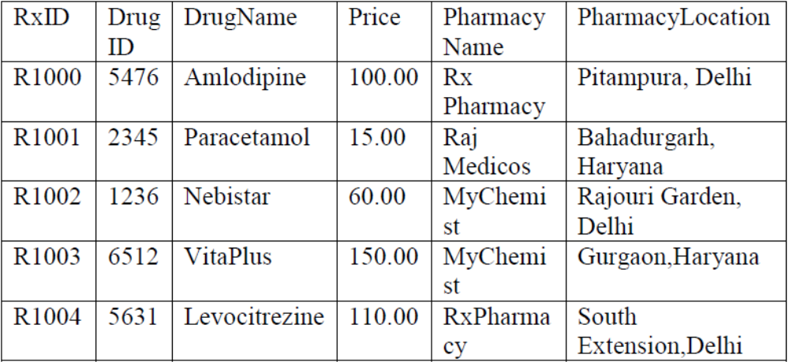  Write commands in SQL to increase the price of “Amlodipine” by 50.
 | Update PharmaDB set price=price+50 where drugname=”Amlodipine”;

Informatics Practices
My SQL Worksheet-6
(DML – SELECT command)
1. | Pooja, a students of class XI, created a table "Book". Price is a column of this table. To find the details of books whose prices have not been entered she wrote the following query:  Select * from Book where Price = NULL;
 | Select * from book where price is null;
2. | The LastName column of a table "Directory" is given below:
  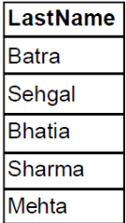 | Based on this information, find the output of the following queries:  a) SELECT lastname FROM Directory WHERE lastname like "_a%";  b)SELECT lastname FROM Directory WHERE lastname not like "%a";
- Lastname
Batra
- Lastname
Sehgal

3. | Consider the table TEACHER given below. Write commands in SQL for (1) to (3) and output for (4)  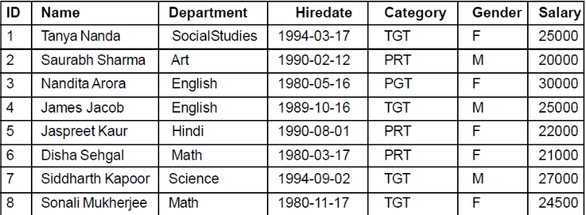  i. To display all information about teachers of PGT category.  ii. To list the names of female teachers of Hindi department.  iii. To list names, departments and date of hiring of all the teachers in ascending order of date of joining  iv. SELECT DISTINCT(category) FROM teacher;
i. Select * from teacher where category=”PGT”;
ii. select name from gym where gender=”F” and department=”Hindi”;
iii. Select name,department,hiredate from teacher order by hiredate;
iv. DISTINCT(Category)
TGT
PRT
PGT

4. | The ltem_No and Cost columna of a table "ITEMS" are given below:
  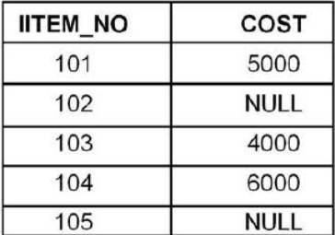 | Based on this information, find the output of the following queries:  a) SELECT COST +100 FROM ITEMS WHERE ITEM_NO > 103;  Ans. COST+100  6100  NULL
5. | Consider the table Projects given below. Write commands in SOL for i) to iii) and output for iv)  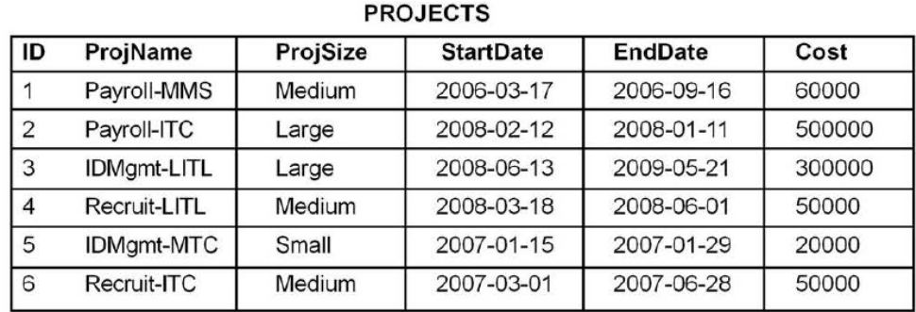  i. To display all information about projects of"Medium" ProjSize  ii. To list the ProjSize of projects whose ProjName ends with LITL.  iii. To list ID, Name, Size, and Cost of all the projects in descending order of StartDate.  iv. SELECT DISTINCT ProjSize FROM projects
i. Select * from projects where projsize=”Medium”;
ii. Select projsize from projects where projname like “%LITL”;
iii. Select ID,projName,projSize,cost from projects order by startDate desc;
iv. ProjSize
Medium
Large
Small
6. | The Mname Column of a table Members is given below :
  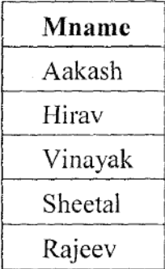 | Based on the information, find the output of the following queries :  (i) Select Mname from members where mname like "%v" ;  (ii) Select Mname from members where mname like "%e%";  Ans. i) Mname  Hirav  Rajeev  ii) Mname  Sheetal  Rajeev
7. | Sarthya, a student of class XI, created a table "RESULT". Grade is one of the column of this table. To find the details of students whose Grades have not been entered, he wrote the following MySql query, which did not give the desired result.  SELECT * FROM Result WHERE Grade= "Null";  Help Sarthya to run the query by removing the errors from the query and write the correct Query.
 | Select * from Result where Grade is null;
8. | Consider the table RESULT given below. Write commands in MySql for (i) to (ii)  (i) To list the names of those students, who have obtained Division as FIRST in the ascending order of NAME.  (ii) To display a report listing NAME, SUBJECT and Annual stipend received assuming that the stipend column has monthly stipend.
- Select name from Result where division=”First” order by name;
- Select name,subject,stipend*12 from Result;

9. | Mr. Janak is using a table with following columns :  Name , Class , Course_Id, Course_name  He needs to display names of students, who have not been assigned any stream or have been assigned Course_name that ends with "economics". He wrote the following command, which did not give the desired result.  SELECT Name, Class FROM Students WHERE Course name = NULL OR Course name="%economics";  Help Mr. J anak to run the query by removing the error and write the correct query.
 | SELECT Name, Class FROM Students WHERE Course name IS NULL OR Course name LIKE "%economics";
10. | Consider the Table SHOPPE given below. Write command in MySql for (i) to (ii)  (i) To display names of the items whose name starts with 'C' in ascending order of Price.  (ii) To display Code, Item name and City of the products whose quantity is less than 100.
- Select Item from shoppe where item like “C%” order by price;
- Select code,item,city from shoppe where qty<100;

11. | What is used in the SELECT clause to return all the columns in the table?
 | * (asterisk) sign
12. | In MySQL, Sumit and Fauzia are getting the following outputs of ItemCodes for SELECT statements used by them on a table named ITEM.(Both have used the SELECT statements on the same table ITEM).  Which extra keyword has Fauzia used with SELECT statement to get the above output?
  Sumit’s Output | Fauzia’s Output
    101
    102
    101
    105
    101
    107
    101
    102
    105
    107
 | Distinct
13. | Consider the table ‘PERSONS’ given below. Write commands in SQL for (i) to (iv) and write output for (v).  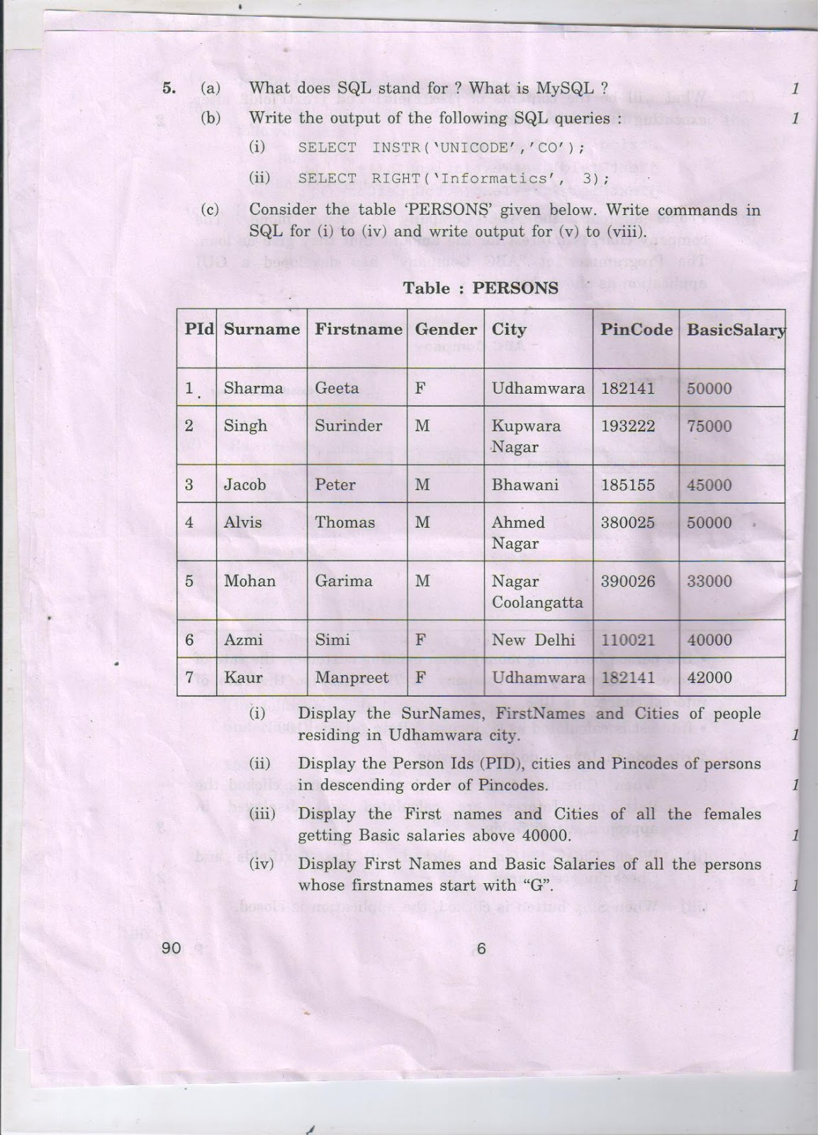  - Display the SurNames, FirstNames and Cities of people residing in Udhamwara city.  - Display the Person Ids (PID), cities and Pincodes of persons in descending order of Pincodes.  - Display the First Names and cities of all the females getting Basic salaries above 40000.  - Display First Names and Basic Salaries of all the persons whose firstnames starts with “G”.  - SELECT Surname FROM Persons Where BasicSalary>=50000;
- Select surname,firstname,city from persons where city=”Udhamwara”;
- Select pid,city,pincode from persons order by pincode desc;
- Select firstname,city from persons where gender=”F” and basicSalary>40000;4
- Select firstname,basicSalary from persons where firstname like “G%”;
- Surname
Sharma
Singh
Alvis
14. | Mr. Tondon is using table EMP with the following columns.  ECODE,DEPT,ENAME,SALARY  He wants to display all information of employees (from EMP table) in ascending order of ENAME and within it in ascending order of DEPT. He wrote the following command, which did not show the desired output.  SELECT * FROM EMP ORDER BY NAME DESC,DEPT;  Rewrite the above query to get the desired output.
 | SELECT * FROM EMP ORDER BY ENAME,DEPT;
15. | Consider the following table named "GYM" with details about fitness items being sold in the store. Write command of SQL for (i) to (ii).  (i) To display the names of all the items whose name starts with "A".  (ii) To display ICODEs and INAMEs of all items, whose Brandname is Reliable or Coscore.
- Select iname from gym where iname like “A%”;
- Select ICode,Iname from gym where brandname in(“Reliable”,”Coscore”);

16. | Consider the following table named 'SBOP" with details of account holders. Write commands of MySql for (i) to (ii) and output for (iii).  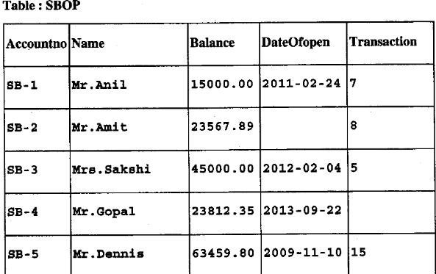  (i) To display Accountno, Name and DateOfopen of account holders having transactions more than 8.  (ii) To display all information of account holders whose transaction value is not mentioned.  (iii) SELECT NAME,BALANCE FROM SBOP WHERE NAME LIKE “%i”;
- Select AccountNo,Name,Dateofopen from sbop where transaction>8;
- Select * from sbop where transaction is null;
- Name Balance
Mrs. Sakshi 45000.00

17. | When using the LIKE clause, which wildcard symbol represents any sequence of none, one or more characters ?
 | %
18. | Consider the table FLIGHT given below. Write commands in SQL for (i) to (iv) and output for (v).  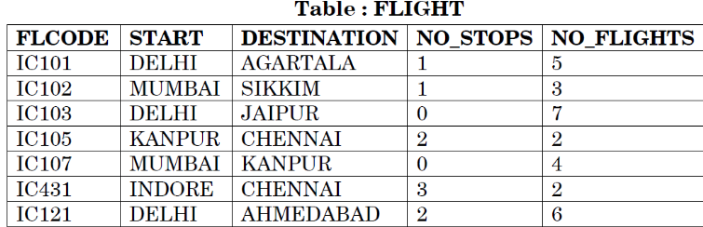  (i) Display details of all flights starting from Delhi.  (ii) Display details of flights that have more than 4 number of flights operating.  (iii) Display flight codes, starting place, destination, number of flights in descending order of number of flights.  (iv) Display destinations along with flight codes of all the destinations starting with ‘A’.  (v) SELECT DISTINCT(NO_STOPS) FROM FLIGHT;
- Select * from flight where start=”Delhi”;
- Select * from flight where no_flights>4;
- Select flcode,start,destination,no_flights from flight order by no_flights desc;
- Select destination,flcode from flight where destination like “A%”;
- NO_STOPS
0
1
2
3

19. | What will be the output of the following queries on the basis of Employee table:  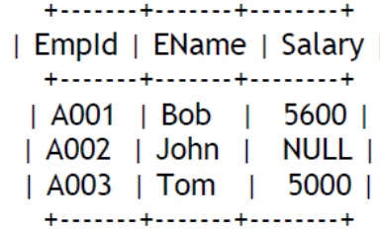  (i) Select Salary+100 from Employee where EmpId='A002';
- Salary +100
NULL

20. | Pranay, who is an Indian, created a table named “Friends” to store his friend’s detail.  Table “Friends” is shown below. Write commands in SQL for (i) to (iii) and output for (iv). 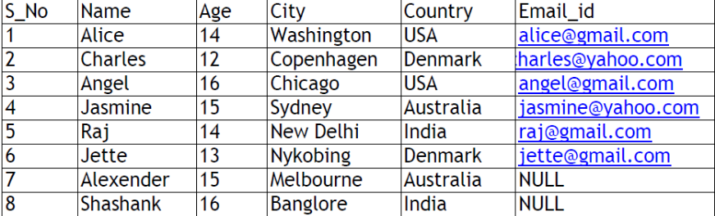  i. To display list of all foreigner friends.  ii. To list name, city and country in descending order of age.  iii. To list name and city of those friends who don’t have an email id.  iv. Select name,country from friends where age>12 and name like ‘A%’;
- Selct * from friends where country not in(“India”);
- Select name,city,country from friends order by age desc;
- Select name,city from friends where email_id is null;
- Name Country
Alice USA
Angel USA
Alexender Australia

21. | Consider the following table named “GARMENT”. Write command of SQL for (i)  to (iv) and output for (v) to (vii).  (i) To display names of those garments that are available in ‘XL’ size.  (ii) To display codes and names of those garments that have their names starting with ‘Ladies’.  (iii) To display garment names, codes and prices of those garments that have  price in the range 1000.00 to 1500.00 (both 1000.00 and 1500.00 included).  (iv) SELECT GNAME FROM GARMENT WHERE SIZE IN (‘M’, ‘L’) AND PRICE > 1500;
- Select gname from garment where size=”XL”;
- Select gcode,gname from garment where gname like “Ladies%”;
- Select gname,gcode,price where price between 1000.00 and 1500.00
- Gname
Jeans

22. | 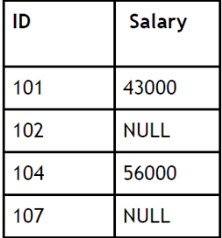Consider the table ‘empsalary’.  To select tuples with some salary ,Siddharth has written the following erroneous SQL  statement:  SELECT ID, Salary FROM empsalary WHERE Salary = something;
 | SELECT ID, Salary FROM empsalary WHERE Salary is not null;
23. | 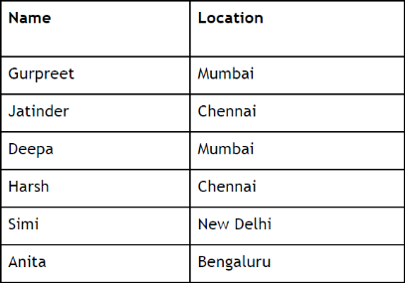Consider the table ‘Employee’.  Write the SQL command to obtain the following output :  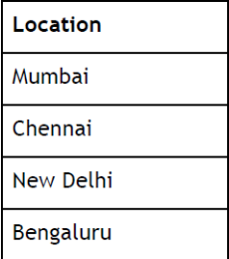
 | Select distinct Location from employee;
24. | Table “Emp” is shown below. Write commands in SQL for (i) to (iii) and output for (iv) and (v)  and (vi)  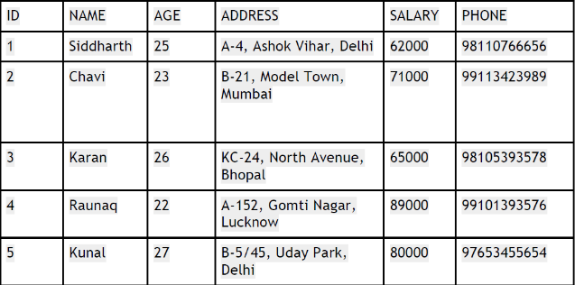i. To display list of all employees below 25 years old.  ii. To list names and respective salaries in descending order of salary.  iii. To list names and addresses of those persons who have ‘Delhi’ in their address.  iv. SELECT Name, Salary FROM Emp where salary between 50000 and 70000;  v. SELECT Name, phone from emp where phone like ‘99%’;
    - Select * from emp where age<25;
    - Select name,salary from emp order by salary desc;
    - Select name,address where address like “%Delhi%”;
    - Name salary
Siddharth 62000
Karan 65000
    - Name Phone
Chavi 99113423989
Raunaq 99101393576

25. | Mrs. Sen entered the following SQL statement to display all Salespersons of the cities “Chennai” and ‘Mumbai’ from the table ‘Sales’.  Rewrite the correct statement, if wrong or write statement is correct.
   | SELECT * FROM Sales WHERE City=‘Chennai’ AND City=‘Mumbai’;
    Scode | Name | City
    101 | Aakriti | Mumbai
    102 | Aman | Chennai
    103 | Banit | Delhi
    104 | Fauzia | Mumbai
 | SELECT * FROM Sales WHERE City=‘Chennai’ OR City=‘Mumbai’;
26. | Write commands in SQL for (i) to (iii) and output for (iv).  Table : Store  (i) To display name, location, city, SalesAmount of stores in descending order of SalesAmount.  (ii) To display names of stores along with SalesAmount of those stores that have ‘fashion’ anywhere in their store names.  (iii) To display Stores names, Location and Date Opened of stores that were opened before 1st March, 2015.  (iv) SELECT distinct city FROM store;
  StoreId | Name | Location | City | NoOfEmployees | DateOpened | SalesAmount
  S101 | Planetfashion | KarolBagh | Delhi | 7 | 2015-10-16 | 300000
  S102 | Trends | Nehru  Nagar | Mumbai | 11 | 2015-08-09 | 400000
  S103 | Vogue | Vikas  Vihar | Delhi | 10 | 2015-06-27 | 200000
  S104 | Superfashion | Defence  Colony | Delhi | 8 | 2015-02-18 | 450000
  S105 | Rage | Bandra | Mumbai | 5 | 2015-09-22 | 600000
- Select name,location,city,salesamount from Store order by salesamount desc;
- Select name,salesamount from store where name like “%Fashion%”;
- Select name,location,dateOpened from store where dateOpened<”2015-03-01”;
- CITY
Delhi
Mumbai

27. | Which clause would you use with Select to achieve the following:  i.To select the values that match with any value in a list of specified values.  ii.Used to display unrepeated values of a column from a table.
i. IN
ii. DISTINCT

28. | Consider the following table:  Table: PharmaDB  Write commands in SQL for (i) to (iii) and output for (iv):  i. To increase the price of “Amlodipine” by 50.  ii. To display all those medicines whose price is in the range 100 to 150.  iii. To display the Drug ID, DrugName and Pharmacy Name of all the records in descending order of their price.  iv. SELECT RxID, DrugName, Price from PharmaDB where PharmacyName IN (“Rx Parmacy”, “Raj Medicos”);
    - Update PharmaDB set price=price+50 where drugname=”Amlodipine”;
    - Select * from pharamdb where price between 100 and 150;
    - Select DrugID,Drugname,pharmacyName from pharmaDB order by price desc;
    - RXID DrugName price
R1000 Amlodipine 100.00
R1001 Paracetamol 15.00
R1004 Levocitrezine 110.00

29. | Write SQL statement that gives the same output as the following SQL statement but uses ‘IN’ keyword.  SELECT NAME FROM STUDENT WHERE STATE = ‘VA’ ;
 | SELECT NAME FROM STUDENT WHERE STATE IN(‘VA’);
30. | Which one of the following SQL queries will display all Employee records containing the word “Amit”, regardless of case (whether it was stored as AMIT, Amit, or amit etc.) ?  (i) SELECT * from Employees WHERE EmpName like UPPER ‘%AMIT%’;  (ii) SELECT *from Employees WHERE EmpName like ‘%AMIT%’ or ‘%AMIT%’ OR ‘%amit%’;  (iii) SELECT * from Employees WHERE UPPER (EmpName) like ‘%AMIT%’;
 | (iii) SELECT * from Employees WHERE UPPER (EmpName) like ‘%AMIT%’;
31. | Write Answer to (i). Write SQL queries for (ii) to (vii).  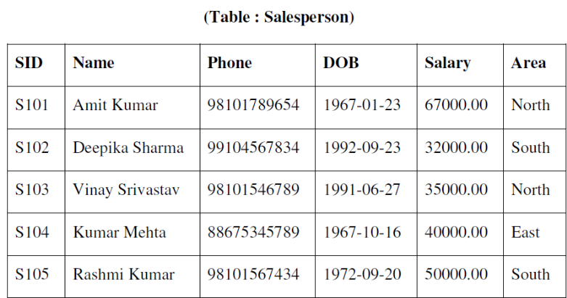  Note : Columns SID and DOB contain Sales Person Id and Data of Birth respectively.  (i) Write the data types of SID and DOB columns.  (ii) Display names of Salespersons and their Salaries who have salaries in the range 30000.00 to 40000.00  (iii) To list Names, Phone numbers and DOB (Date of Birth) of Salespersons who were born before 1st November, 1992.  (iv) To display Names and Salaries of Salespersons in descending order of salary.  (v) To display areas in which Salespersons are working. Duplicate Areas should not be displayed.  (vi) To display SID, Names along with Salaries increased by 500. (Increase of 500 is only to be displayed and not to be updated in the table)  (vii) To display Names of Salespersons who have the word ‘Kumar’ anywhere in their names.
    - The data type of SID is either char or varchar
    - Select name,salary from salesperson where salary between 30000.00 and 40000.00;
    - Select name,phone,dob from salesperson where dob<”1992-11-01”;
    - Select name,salary from salesperson order by salary desc;
    - Select distinct area from salesperson;
    - Select sid,name,salary+500 from salesperson;
    - Select name from salesperson where name like “%Kumar%”;

32. | Write the following statement using ‘OR’ logical operator :  SELECT first_name, last_name, subject FROM studentdetails WHERE subject IN (‘Maths’, ‘Science’);
 | Select first_name, last_name, subject from studentDetails Where subject=”Maths” or subject=”Science”;
33. | Consider the Table “Gym” shown below. Write commands in SQL for (i) to (vi) :  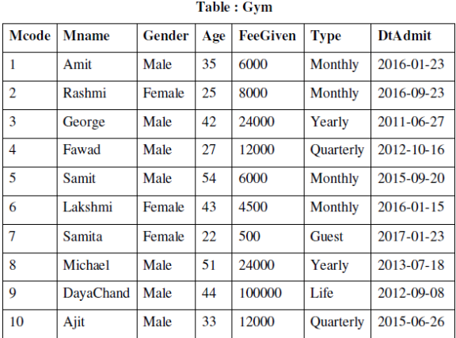  (i) To display Mname, Age, FeeGiven of those members whose fee is above 12,000.  (ii) To display Mcode, Mname, Age of all female members of the Gym with age in descending order.  (iii) To list names of members and their date of admission of those members who joined after 31st December, 2015.  iv) To display the Mname, FeeGiven of all those members of the Gym whose age is less than 40 and are monthly type members of the Gym.  (v) To display names of members who have ‘mit’ anywhere in their names. For example : Amit, Samit.  (vi) To display types of memberships available. Duplicate values should not be displayed.
- Select mname, age, feegiven from gym where feegiven>12000;
- Select mcode,mname,age from gym where gender=”Female” order by age desc;
- Select mname,dtAdmit from gym where dtAdmit>”2015-12-31”;
- Select mname,feegiven from gym where age<40 and type=”Monthly”;
- Select mname from gym where mname like “%mit%”;
- Select distinct type from gym;

34. | Consider the following table:  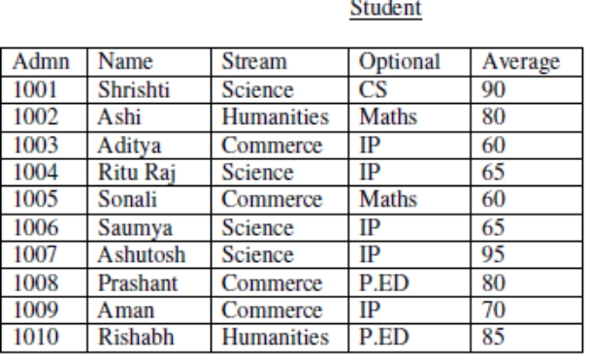Write commands in SQL for (i) to (iv) and output for (v):  i. To display the details of all those students who have IP as their optional subject.  ii. To display name, stream and optional of all those students whose name starts with ‘A’.  iii. To give an increase of 3 in the average of all those students of humanities section who have Maths as their optional subject.  iv. To display a name list of all those students who have average more than 75.  v. Select name from students where optional IN (‘CS’,’IP’);
- Select * from student where optional=”IP”;
- Select name,stream,optional from student where name like “A%”;
- Update student set average=average+3 where stream=”Humanities”;
- Select name from student where average>75;
- Name
Shrishti
Aditya
Ritu Raj
Saumya
Ashutosh
Aman

Informatics Practices
My SQL Worksheet-7
(Single Row Functions)
1. | Write the output of the following SQL queries:  a) SELECT ROUND(6.5675, 2); 6.57  b) SELECT TRUNCATE(5.3456, 1); 5.3  c) SELECT DAYOFMONTH('2009-08-25'); 25  d) SELECT MID('Class 12', 2,3); las
2. | Write the output of the following SQL queries :  - SELECT INSTR(‘UNICODE’,’CO’); 4  - SELECT RIGHT(‘Informatics’,3); ics
3. | State difference between date functions NOW( ) and SYSDATE( ) of MySql.
Now() | Sysdate()
Now displays the date and time at the beginning of the command. | Sysdate() displays the date and time at the exact time of the execution of the command.
It always displays the same date and time in a single sql command. No matter how many times it is being executed. | It displays the exact date and time at which it is executed within the single command.
Example:
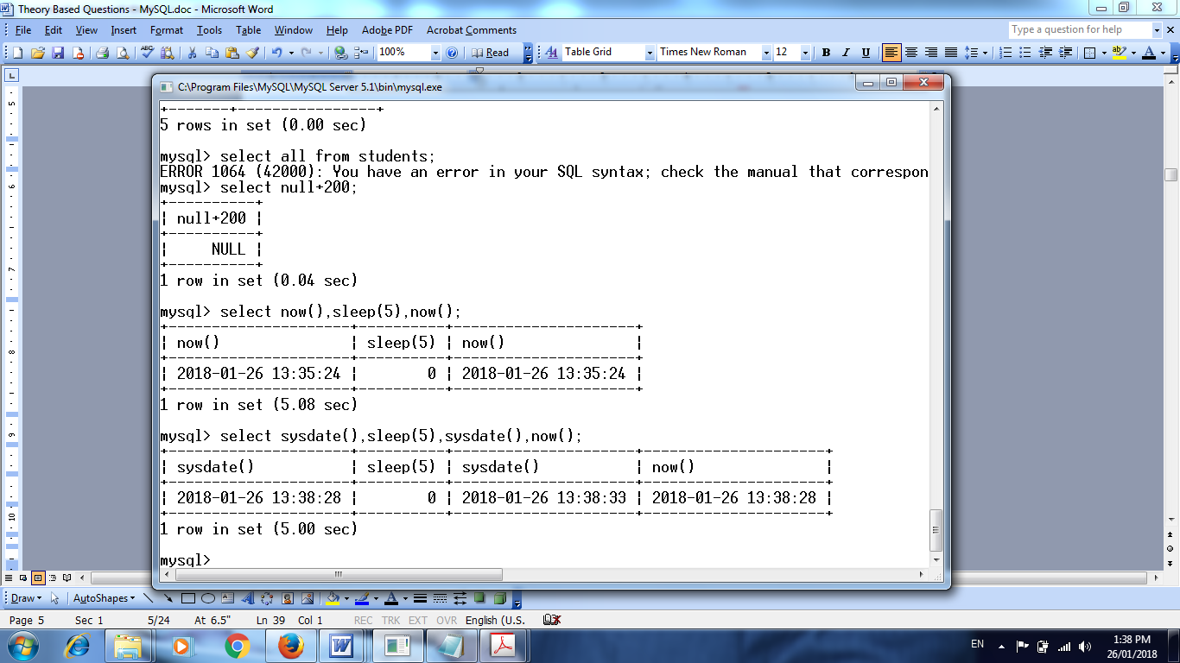

4. | Name a function of MySql which is used to remove trailing and leading spaces from a string.
 | trim
5. | Consider the following table named 'SBOP" with details of account holders. Write output  (i) SELECT ROUND(Balance,-3) FROM SBOP WHERE AccountNo=”SB-5”;  Ans. i)  ROUND(Balance,-3)  63000
6. | Write the output of the following SQL queries :  (i) SELECT RIGHT(‘software’, 2); re  (ii) SELECT INSTR(‘twelve’,‘lv’); 4  (iii) SELECT DAYOFMONTH(‘2014-03-01’); 1  (iv) SELECT ROUND(76.987, 2); 76.99
7. | Write the output of the following SQL queries:  i. SELECT INSTR(‘INTERNATIONAL’, ‘NA’); 6  ii. SELECT LENGTH(CONCAT(‘NETWORK’,’ING’)); 10  iii.SELECT ROUND(563.345,-2); 600  iv. SELECT DAYOFYEAR(‘2014-01-30’); 30
8. | Pranay, who is an Indian, created a table named “Friends” to store his friend’s detail.  Table “Friends” is shown below. Write output for (i) and (ii).  i. Select ucase(concat(name,”*”,city)) from friends where country like ‘Denmark’;  ii. Select mid(name,1,4) as “UID” from friends where country like ‘USA’;
- ucase(concat(name,”*”,city))
CHARLES*COPENHAGEN
JETTE*NYKOBING
- UID
Alic
Ange
9. | Write the output of the following SQL queries:  i) SELECT TRUNCATE(8.975,2); 8.97  ii) SELECT MID(‘HONESTY WINS’,3,4); NEST  iii) SELECT RIGHT(CONCAT(‘PRACTICES’,’INFORMATICS’),5); ATICS  iv) SELECT DAYOFMONTH(‘2015-01-16’); 16
10. | Write the output of the following SQL queries :  (i) SELECT MID(‘BoardExamination’,2,4); oard  (ii) SELECT ROUND(67.246,2); 67.25  (iii) SELECT INSTR(‘INFORMATION FORM’,‘FOR’); 3  (iv) SELECT DAYOFYEAR(‘2015-01-10’); 10
11. | Write output.  Table : Store  (i) SELECT Name, length (name), left (name, 3) FROM Store where NoOfEmployees<3;
  StoreId | Name | Location | City | NoOfEmployees | DateOpened | SalesAmount
  S101 | Planetfashion | KarolBagh | Delhi | 7 | 2015-10-16 | 300000
  S102 | Trends | Nehru  Nagar | Mumbai | 11 | 2015-08-09 | 400000
  S103 | Vogue | Vikas  Vihar | Delhi | 10 | 2015-06-27 | 200000
  S104 | Superfashion | Defence  Colony | Delhi | 8 | 2015-02-18 | 450000
  S105 | Rage | Bandra | Mumbai | 5 | 2015-09-22 | 600000
 | - Empty Set
12. | Write the output of the following SQL queries:  SELECT POW(INSTR(‘My_Database’,’_’),2); 9
13. | Consider the table given below :  Write output.  (i) SELECT Name, LENGTH(Name) FROM Salesperson;  Ans.  Name Length()  Amit Kumar 10  Deepika Sharma 14  Vinay Srivastav 15  Kumar Mehta 11  Rashmi Kumar 12
14. | Identify Single Row functions of MySQL amongst the following :  TRIM(), MAX(), COUNT(*), ROUND()
 | Trim() and Round() are single row functions
15. | Consider the Table “Gym” and write output  (i) SELECT MID(Mname,1,2)from Gym;  Ans.  MID(Mname,1,2)  Am  Ra  Ge  Fa  Sa  La  Su  Mi  Da  Aj
16. | Observe the given table named “Loan” carefully and predict the output of the  following queries:  - 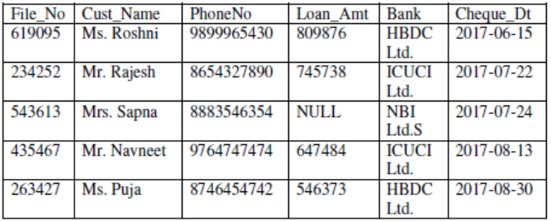SELECT concat(left(file_no,2), right(cust_name,2)) AS “ID” from loan where Bank='ICUCI Ltd.';  - select round(loan_amt-loan_amt*10/100) As "Discounted Payment" from loan where loan_amt>700000;
- ID
23mi
43et
- Discounted Payment
728888
671164

Informatics Practices
My SQL Worksheet-8
(Aggregate Functions)
1. | Consider the table TEACHER given below. Write commands in SQL for (1) and output for (2) to (5)  i. To count the number of teachers in English department.  ii. SELECT MAX(Hiredate) FROM Teacher;  iii. SELECT DISTINCT(category) FROM teacher;  iv. SELECT COUNT(*) FROM TEACHER WHERE Category = "PGT"  v. SELECT Gender,AVG(Salary) FROM TEACHER group by Gender;
i. Select count(*) from teacher where department=”English”;
ii. Max(Hiredate)
1994-09-02
iii. Distinct(Category)
TGT
PRT
PGT
iv Count(*)
1
v. Gender avg(salary)
M 24000
F 24500

2. | The ltem_No and Cost column of a table "ITEMS" are given below:
  Based on this information, find the output of the following queries:
  a) SELECT AVG(COST) FROM ITEMS;
  b) SELECT COST +100 FROM ITEMS WHERE ITEM_NO > 103;
- AVG(Cost)
5000
- Cost+100
6100
Null

3. | "PrincipaiName" is a column in a table "Schools". The SOL queries  SELECT count(*) FROM Schools;  and  SELECT count( Principal) FROM schools;  Give the result 28 and 27 respectively. What may be the possible reason for this? How many records are present in the table-27 or 28?
The possible reason could be that one of the value in Principal field will be NULL
There are 28 records

4. | Consider the table Projects given below. Write commands in SOL fori) and output for i) to iii)  i. To count the number of projects of cost less than 100000.  ii. SELECT SUM(Cost) FROM projects;  iii. SELECT ProjSize, COUNT(*) FROM Projects GROUP BY ProjSize;
i. Select count(*) from projects where cost<100000;
ii. Sum(cost)
980000
- Projesize count(*)
Medium 3
Large 2
Small 1

5. | Consider the table RESULT given below. Write output  (i) SELECT AVG(Stipend) FROM EXAM WHERE DIVISION= "THIRD”;  (ii) SELECT COUNT(DISTINCT Subject) FROM EXAM;  (iii) SELECT MIN(Average) FROM EXAM WHERE Subject= "English";
i) AVG(Stipend)
475
ii) Count(distinct subject)
6
iii) Min(Average)
38

6. | What is the purpose of ORDER BY clause in MySql ? How is it different from GROUP BY clause?
Order by displays the records in ascending/descending order of field.
Group By, groups the records according to a field and then finds the maximum or minimum or counts or finds the sum or average.
7. | Consider the Table SHOPPE given below. Write command in MySql for (i) and output for (ii) to (iii).  (i) To count distinct Company from the table.  (ii) Select Count(distinct (City)) from Shoppe;  (iii) Select MIN (Qty) from Shoppe where City="Mumbai";
- Select count(distinct company) from shoppe;
- Count(distinct (city))
3
- Min(Qty)
56

8. | Consider the table ‘PERSONS’ given below. Write commands in SQL for (i) to (iv) and write output for (i) to (iii).  - SELECT SUM(BasicSalary) FROM Persons Where Gender=’F’;  - SELECT Gender,MIN(BasicSalary) FROM Persons GROUP BY gender;  - SELECT Gender,Count(*) FROM Persons GROUP BY Gender;
- SUM(BasicSalary)
132000
- Gender MIN(BasicSalary)
F 40000
M 33000
- Gender Count(*)
F 3
M 4

9. | There is a column HOBBY in a Table CONTACTS. The following two statements are giving different outputs. What may be the possible reason ?  SELECT COUNT(*) FROM CONTACTS;  SELECT COUNT(HOBBY)FROM CONTACTS;
 | The possible reason could be that some of the values in the hobby field would be NULL.
10. | Consider the following table named "GYM" with details about fitness items being sold in the store. Write output  (i) SELECT COUNT (DISTINCT (BRANDNAME)) FROM GYM;  (ii) SELECT MAX (PRICE ) FROM GYM;  Ans. i) COUNT (DISTINCT (BRANDNAME))  6  ii) Max(Price)  30000
11. | Consider the following table named 'SBOP" with details of account holders. Write output.  (i) SELECT COUNT(*) FROM SBOP;  Ans. COUNT(*)  5
12. | Given ‘Employee’ table as follows :  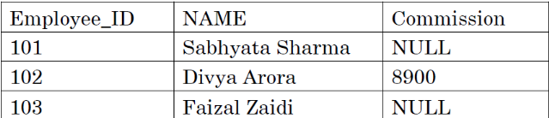  What values will the following statements return ?  SELECT COUNT(*) FROM Employee;  SELECT COUNT(Commission) FROM Employee;  Ans. Count(*)  3  Count(Commission)  1
13. | Consider the table FLIGHT given below. Write output.  (i) SELECT MAX(NO_FLIGHTS) FROM FLIGHT;  (ii) SELECT START, COUNT(*) FROM FLIGHT GROUP BY Start;
- MAX(NO_FLIGHTS)
7
- START COUNT(*)
Delhi 3
Mumbai 2
Kanpur 1
Indore 1

14. | What will be the output of the following queries on the basis of Employee table:  (i)Select avg(Salary) from Employee;  (ii) Select Salary+100 from Employee where EmpId='A002';
- Avg(Salary)
5300
- Salary+100
NULL

15. | Consider the following table named “GARMENT”. Write output  (i) SELECT COUNT(DISTINCT (SIZE)) FROM GARMENT;  (ii) SELECT AVG(PRICE) FROM GARMENT;  Ans. i) COUNT(DISTINCT (SIZE))  3  ii) AVG(PRICE)  1800
16. | Consider the table ‘Teacher’ given below.  What will be the output of the following queries on the basis of the above table:  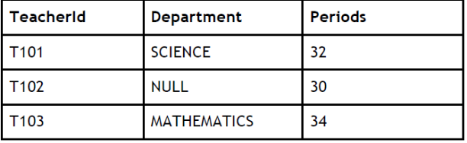(i)Select count(Department) from Teacher;  (ii)Select count(*) from Teacher;  Ans. count(Department)  2  count(*)  3
17. | (i) Name two Aggregate (Group) functions of SQL.  (ii) Consider the table :
  Table : Company | What output will be displayed by the following SQL statement ?  SELECT AVG(SALES) FROM Company;  AVG(SALES)  15000
    SID | SALES
    S101 | 20000
    S103 | NULL
    S104 | 10000
    S105 | 15000
18. | Consider the table ‘Hotel’ given below :
  Table : Hotel | Mr. Vinay wanted to display average salary of each Category. He entered the following SQL statement. Identify error(s) and Rewrite the correct SQL statement.  SELECT Category, Salary FROM Hotel  GROUP BY Category;  Select category,avg(salary) from hotel group by category;
    EMPID | Category | Salary
    E101 | MANAGER | 60000
    E102 | EXECUTIVE | 65000
    E103 | CLERK | 40000
    E104 | MANAGER | 62000
    E105 | EXECUTIVE | 50000
    E106 | CLERK | 35000
19. | Explain why the following queries give different outputs on execution:  i. SELECT COUNT(ENAME) FROM EMP;  Output: 5  ii. SELECT Count(*) FROM EMP;  Output: 8
 | The ename field in emp table will be having 3 NULL values
20. | Kunal has entered the following SQL command on Table ‘STUDENT’ that has TotalMarks as one of the columns.  SELECT COUNT (*) FROM STUDENT;  The output displayed is 20.  Then, Kunal enters the following command :  SELECT COUNT (*) FROM STUDENT WHERE TotalMarks <100;  The output displayed is 15.  Then, Kunal enters the following command :  SELECT COUNT (*) FROM STUDENT WHERE TotalMarks >= 100;  He predicts the output of the above query as 5. Do you agree with Kunal ? Give reason for your answer.
 | Yes, the output for select count(*) from student where totalMarks>=100 will be 5 as there are 20 students out of which 15 have totalMarks less than 100 so 5 students will have a totalMarks greater than or equal to 100
21. | Consider the table given below :  Write command for (i) and output for (ii)  (i) To display Area along with number of Salespersons working in that area.  (ii) SELECT Area, COUNT (*) FROM Salesperson GROUP BY Area HAVING COUNT (*) > 1;  i) Select area,count(*) from salesperson group by area;  ii) Area Count(*)  North 2  South 2
22. | Observe the given table named “Loan” carefully and predict the output of the  following queries:  select count(file_no)-count(loan_amt) from loan;  count(file_no)-count(loan_amt)  1
Informatics Practices
My SQL Worksheet-9
(Joins)
1. | In a database there are two tables 'Customer' and 'Bill' as shown below:  (i) How many rows and how many columns will be there in the Cartesian product of these two tables?  (ii) Which column in the 'Bill' table is the foreign key?
  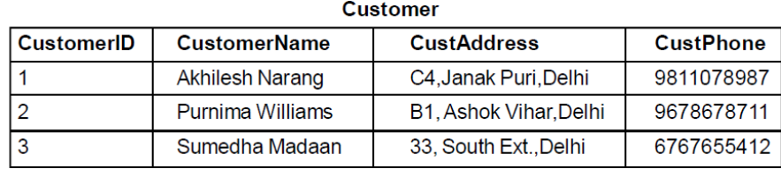 | 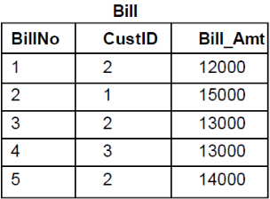
i) There will be 5 columns and 15 rows in the Cartesian product of these two tables.
ii) CustID in the bill table is a foreign key

2. | Consider the tables HANDSETS and CUSTOMER given below:  With reference to these tables, Write commands in SQL for (i) and (ii) and output for (iii) below:  (i) Display the CustNo, CustAddress and corresponding SetName for each customer.  (ii) Display the Customer Details for each customer who uses a Nokia handset.  (iii) select SetNo, SetName from Handsets, customer where SetNo = SetCode and CustAddress = 'Delhi';
  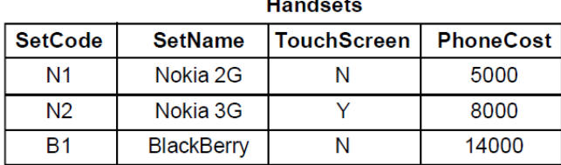 | 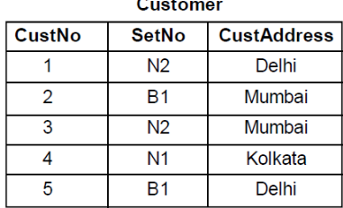
i) Select custno, custaddress, setname
from handsets, customer
where setcode=setno;
ii) Select customer.*
from handsets, customer
where setcode=setno and setname like “Nokia%”;
iii) SetNo SetName
N2 Nokia 3G
B1 BlackBerry

3. | In a database there are two tables "Company" and "Model" as shown below:  (i) Identify the foreign key column in the table Model.  (ii) Check every value in CompiD column of both the tables. Do you find any discrepancy?
  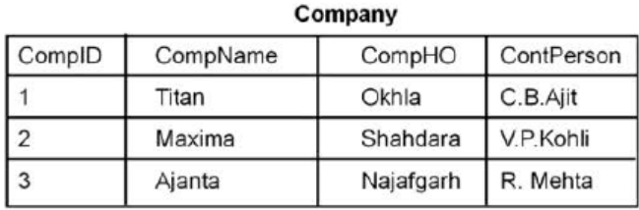 | 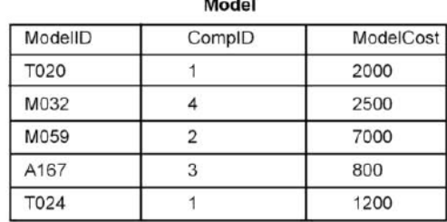
i) ComID is the foreign key in model table
ii) The discrepancy is a value 4 in the compID field of Model table.

4. | Consider the tables DOCTORS and PATIENTS given below:  W1th reference to these tables, wnte commands m SQL for (1) and (II) and output for (iii) below:  (i) Display the PatNo, PatName and corresponding DocName for each patient  (ii) Display the list of all patients whose OPD_Days are MWF.  (iii) select OPD_Days, Count(*) from Doctors, Patients where Patients.Department = Doctors.Department Group by OPD_Days;
  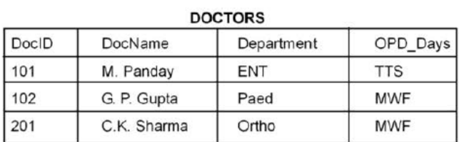 | 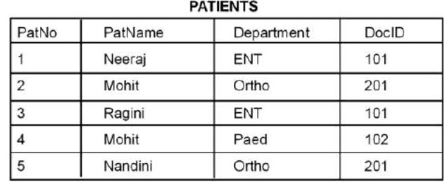
i) Select PatNo, patName, DocName
From Doctors, Patients
Where Doctors.DocID=Patients.DocID;
ii) Select Patients.*
From Doctors, Patients
Where Doctors.docID=Patients.DocID amd OPD_Days=”MWF”;
iii) OPD_Days Count(*)
TTS 2
MWF 3

5. | In a database there are two tables "Product" and "Client" as shown below :  Write the commands in SQL queries for the following :  (i) To display the details of Product whose Price is in the range of 40 and 120 (Both values included)  (ii) To display the ClientName, City from table Client and ProductName and Price from table Product, with their corresponding matching P ID.  (iii) To increase the Price of all the Products by 20.
  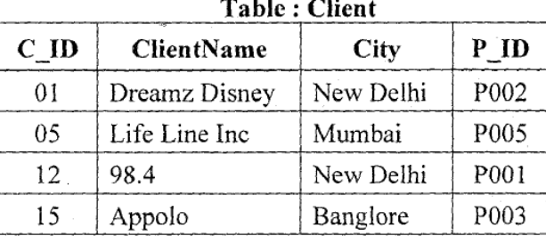
- Select *
From Product
where price between 40 and 120;
- Select clientName,city,productName,price
From Product,Client
Where Product.P_ID=Client.P_ID;
- Update Product
Set price=price+20;

6. | In a. Database School there are two tables Member and Division as show below.  (i) Identify the foreign key in the table Member.  (ii) What output, you will get, when an equi-join query is executed to get the NAME from Member Table and corresponding DivName from Division table ?
  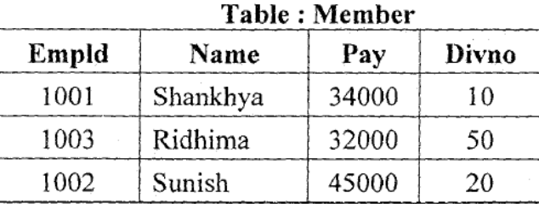 | 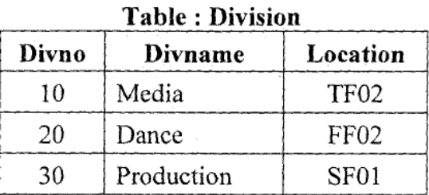
- DivNo is a foreign key in member table
- Name Divname
Shankhya Media
Sunish Dance

7. | In a Database there are two tables :  Write MySql queries for the following :  (i) To display ICode, IName and corresponding Brand of those Items, whose Price is between 20000 and 45000 (both values inclusive).  (ii) To display ICode, Price and BName, of the item which has IName as "Television".  (iii) To increase the price of all the Items by 15%.
  Table ITEM:  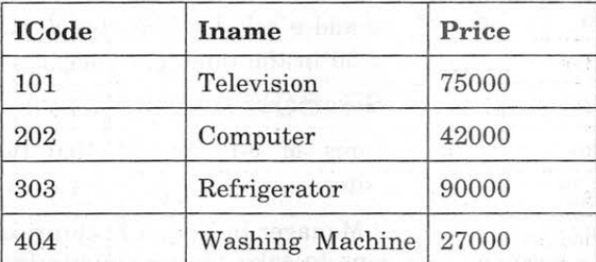 | 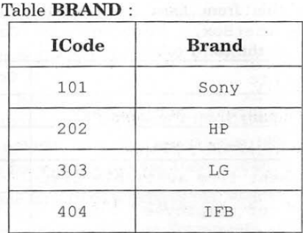
- Select ICode,IName,Brand
From Item,Brand
Where Item.Icode=Brand.ICode and price between 20000 and 45000;
- Select ICode,Price,Brand
From Item,Brand
Where IName IN(“Television”);
- Update Item
Set Price=Price + Price *15/100;

8. | In a Database there are two tables :  (i) Which column can be set as the PRIMARY KEY in the MAGAZINE table?  (ii) Which column in the ‘MAGAZINE’ table is the foreign key?  (iii) How many rows and columns will be there in the Cartesian product of the above 2 tables.  (iv) Write command in SQL to display the mag_code, Mag_Title and corresponding types for all the Magazines.  (v) Write the output :  - Select Mag_Code, Mag_Title, Number_of_Pages, Type From MAGAZINE,MAGTYPE Where Magazine.Mag_Category=Magtype.Mag_Category and Type=’Spiritual’;
  Table MAGAZINE:  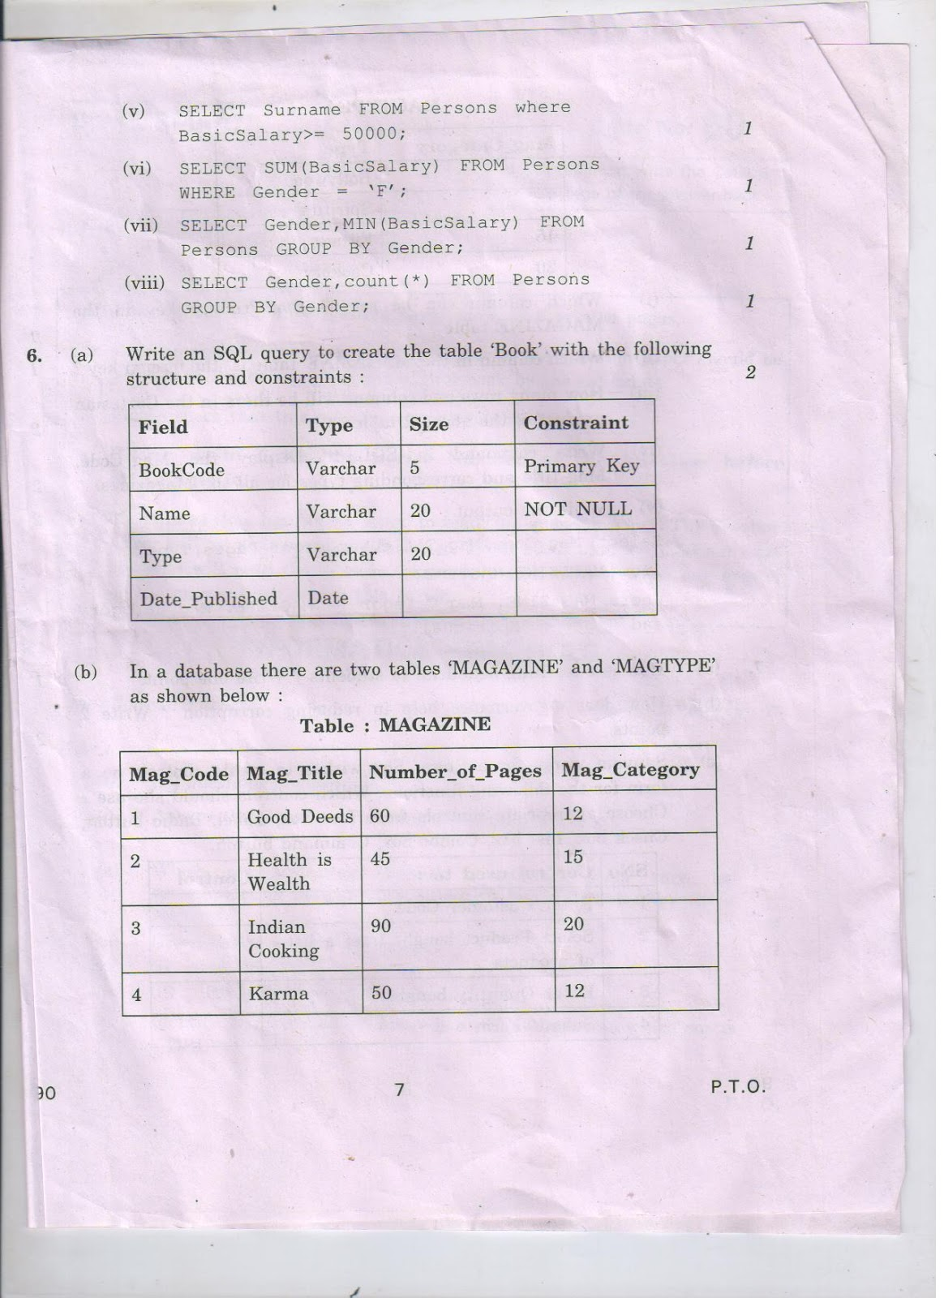 | 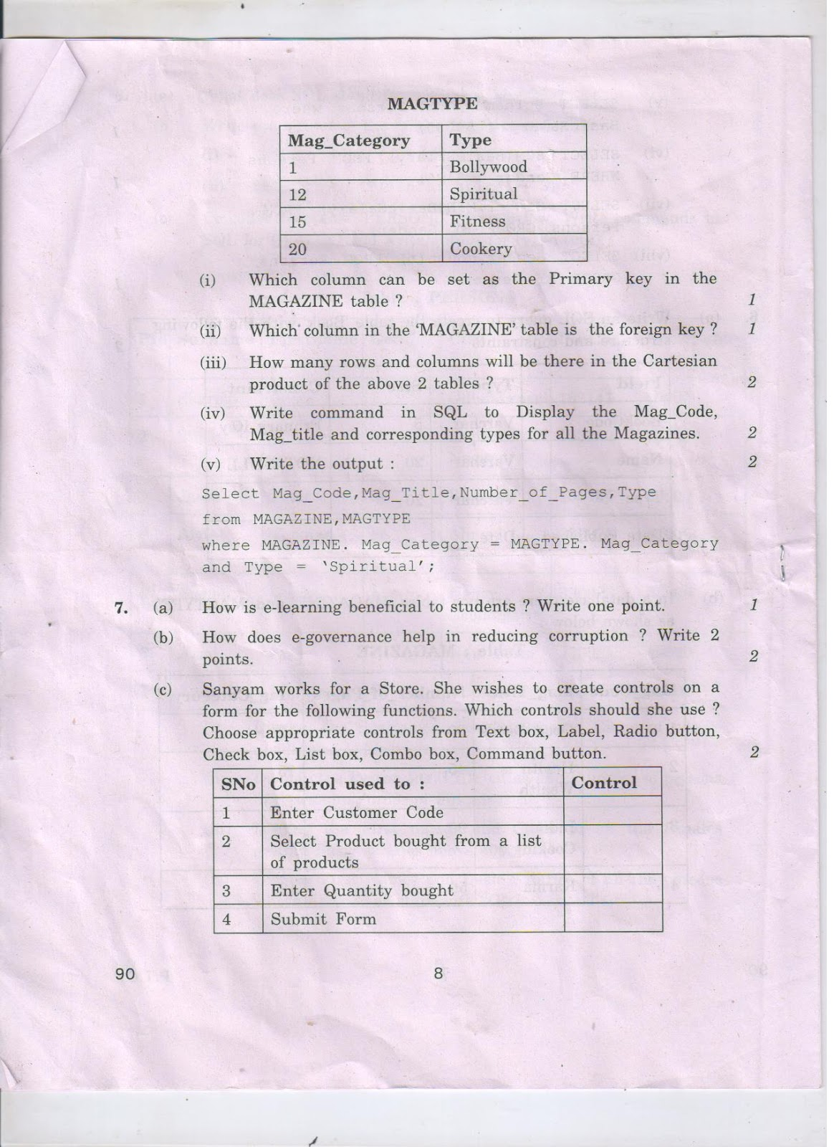
- Mag_Code can be set as primary key in magazine table
- Mag_category is the foreign key in magazine table
- In the Cartesian product of these two tables there will be 6 columns and 16 rows.
- Select Mag_Code, Mag_Title, Type
From Magazine, magType
Where magazine.mag_category=magType.category;
- Mag_Code Mag_Title Number_of_Pages Type
1 Good Deeds 60 Spiritual

9. | In a Database Kamataka_Sangam there are two tables with the instances given below :  Write SQL queries for the following :  (i) To count how many addresses are not having NULL values in the address column of students table.  (ii) To display Name, Class from STUDENT table and the corresponding Grade from SPORTS table.  (iii) To display Name of the student and their corresponding Coachnames from STUDENTS and SPORTS tables.
  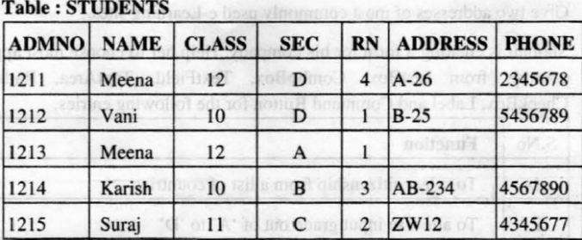 | 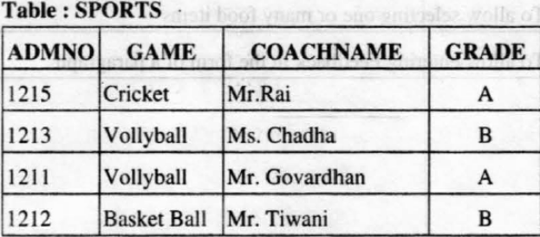
- Select count(*)
from students
where address is not null;
- Select Name,Class,Grade
From students, sports
Where students.admno=sports.admno;
- Select Name,Coachname
From students, sports
Where students.admno=sports.admno;

10. | In a Database Multiplexes, there are two tables with the following data. Write MySQL queries for (i) to (iii), which are based on TicketDetails and AgentDetails :  (i) To display Tcode, Name and Aname of all the records where the number of tickets sold is more than 5.  (ii) To display total number of tickets booked by agent “Mr. Ayush”  (iii) To display Acode, Aname and corresponding Tcode where Aname ends with “k”.  (iv) With reference to “TicketDetails” table, which column is the primary key ? Which column is the foreign key? Give reason(s)
  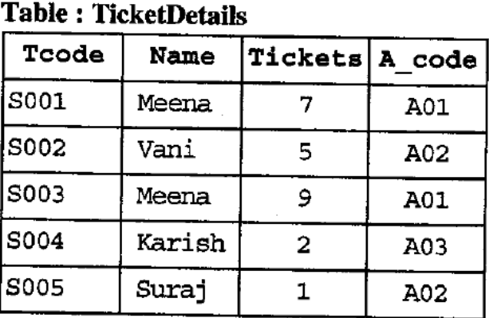 | 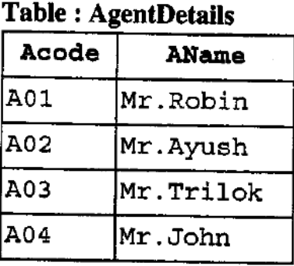
- Select TCode, Name, AName
From TicketDetails, AgentDetails
Where A_Code=Acode and tickets>5;
- Select sum(Tickets)
From TicketDetails, AgentDetails
Where A_Code=Acode and aName=”Mr. Ayush”;
- Select Acode, AName, Tcode
From TicketDetails, AgentDetails
Where A_Code=Acode and Aname like “k%”;
- In TicketDetails TCode is Primary Key and A_code is foreign key as two tickets cannot have same no. whereas the Agent code i.e. A_Code is referencing its values from the Acode field in AgentDetails table.
11. | In a database there are two tables ‘CD’ and ‘TYPE’ as shown below :  (i) Name the Primary key in ‘‘CD’’ table.  (ii) Name the foreign key in ‘‘CD’’ table.  (iii) Write the Cardinality and Degree of ‘‘TYPE’’ table.  (iv) Check every value in CATEGORY column of both the tables. Do you find any discrepancy ? State the discrepancy.
- Code
- Category
- Cardinality = 4 and Degree = 2 of the Type table
- Yes, the discrepancy is a value 77 in category field in CD table.

13. | Consider the tables ‘Flights’ & ‘Fares’ given below:  Flights  Fares  With reference to these tables, write commands in SQL for (i) and (ii) and output for (iii) below:  i. To display flight number, source, airlines of those flights where fare is less than Rs. 10000.  ii. To count total no of Indian Airlines flights starting from various cities.  iii. SELECT FLIGHTS.FNO, NO_OF_FL, AIRLINES FROM FLIGHTS,FARES WHERE FLIGHTS.FNO = FARES.FNO AND SOURCE=’DELHI’;
  FNO | SOURCE | DEST | NO_OF_FL | NO_OF_STOP
  IC301 | MUMBAI | BANGALORE | 3 | 2
  IC799 | BANGALORE | KOLKATA | 8 | 3
  MC101 | DELHI | VARANASI | 6 | 0
  IC302 | MUMBAI | KOCHI | 1 | 4
  AM812 | LUCKNOW | DELHI | 4 | 0
  MU499 | DELHI | CHENNAI | 3 | 3
  FNO | AIRLINES | FARE | TAX
  IC301 | Indian Airlines | 9425 | 5
  IC799 | Spice Jet | 8846 | 10
  MC101 | Deccan Airlines | 4210 | 7
  IC302 | Jet Airways | 13894 | 5
  AM812 | Indian Airlines | 4500 | 6
  MU499 | Sahara | 12000 | 4
- Select Flights.FNO, Source,airlines
From Flights, Fares
Where Flights.FNO=Fares.FNO and fare<10000;
- Select Sum(No_of_Fl)
From Flights, Fares
Where Flights.FNO=Fares.FNO and airlines=”Indian Airlines”;
- FLIGHTS.FNO NO_OF_FL AIRLINES
MC101 6 Deccan Airlines
MU499 3 Sahara

14. | A table STUDENT has 5 rows and 3 columns. Table ACTIVITY has 4 rows and 2 columns. What will be the cardinality and degree of the Cartesian product of them ?
The degree will be 5
The cardinality will be 20

15. | Consider the following table named “GARMENT”.  What is the degree and cardinality of ‘Garment’ table ?  Degree=5  Cardinality=6
16. | In a Database, there are two tables given below :  Write SQL Queries for the following :  (i) To display employee ids, names of employees, job ids with corresponding job titles.  (ii) To display names of employees, sales and corresponding job titles who have achieved sales more than 1300000.  (iii) To display names and corresponding job titles of those employee who have ‘SINGH’ (anywhere) in their names.  (iv) Identify foreign key in the table EMPLOYEE.
- Select EmployeeID, Name, JobID, JobTitle
From Employee, Job
Where Employee.jobid=job.jobid;
- Select Name, Sales, Jobtitle
From Employee, Job
Where Employee.jobid=job.jobid and sales>1300000;
- Select Name, Jobtitle
From Employee, Job
Where Employee.jobid=job.jobid and name like “%Singh%”;
- JobID
17. | Consider the tables given below.  i. The SalespersonId column in the "Salesperson" table is the Primary Key.The  SalespersonId column in the "Orders" table is a Foreign KEY.  ii. Can the ‘SalespersonId’ be set as the primary key in table ‘Orders’. Give reason.
  Salesperson | Orders
  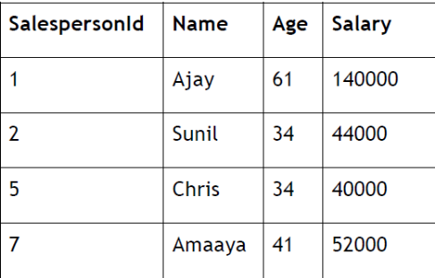 | 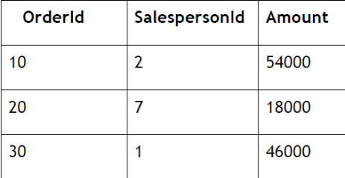  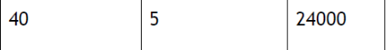
 | Ii. No salespersonID cannot be set as the primary key in orders table as two salesperson can give multiple orders, so the ordered will be primary key and salespersonID will be the foreign key which will refer its values from the salespersonid field of salesperson table.
18. | With reference to the above given tables, Write commands in SQL for (i) and  (ii) and output for (iii) below:  - To display SalespersonID, names, orderids and order amount of all salespersons.  - To display names ,salespersons ids and order ids of those sales persons whose names start with ‘A’ and sales amount is between 15000 and 20000.  - SELECT Salesperson.SalespersonId, name, age, amount FROM Salesperson, orders WHERE Salesperson.salespersonId= Orders.salespersonId AND AGE BETWEEN 30 AND 45;
    - Select Salesperson.salespersonID, Name, OrderID
From Salespersons, orders
Where Salesperson.salespersonID=Orders.SalespersonID;
    - Select Salesperson.salespersonID, Name, OrderID
From Salespersons, orders
Where Salesperson.salespersonID=Orders.SalespersonID
and name like “A%” and amount between 15000 and 20000;
    - Salesperson.SalespersonId name age amount
2 Sunil 34 54000
5 Chris 34 24000

19. | Consider the tables given below :  Table : Faculty  Table : Course  (i) Which column is used to relate the two tables ?  (ii) Is it possible to have a primary key and a foreign key both in one table ? Justify your answer with the help of table given above.
  TeacherId | Name | Address | State | PhoneNumber
  T101 | Savita Sharma | A-151, Adarsh  Nagar | Delhi | 991019564
  T102 | Deepak Ghai | K-5/52, Vikas  Vihar | Mumbai | 893466448
  T103 | MahaLakshmi | D-6 | Delhi | 981166568
  T104 | Simi Arora |  | Mumbai | 658777564
  CourseId | Subject | TeacherId | Fee
  C101 | Introductory Mathematics | T101 | 4500
  C103 | Physics | T101 | 5000
  C104 | Introductory Computer Science | T102 | 4000
  C105 | Advance Computer Science | T104 | 6500
- TeacherID
- Yes, it is possible to have both Primary and foreign key in one table. For Example in the above course table CourseID is a primary key and teacherid is the foreign key.
20. | With reference to the above given tables, write commands in SQL for (i) and (ii)  and output for (iii) :  (i) To display CourseId, TeacherId, Name of Teacher, Phone Number of Teachers living in Delhi.  (ii) To display TeacherID, Names of Teachers, Subjects of all teachers with names of Teachers starting with ‘S’.  (iii) SELECT CourseId, Subject,Course.TeacherId,Name,PhoneNumber FROM  Faculty,Course WHERE Faculty.TeacherId = Course.TeacherId AND Fee>=5000;
- Select coursed, Course.TeacherID, Name, PhoneNumber
From Faculty, Course
Where Faculty.TeacherID=Course.TeacherID and state=”Delhi”;
- Select Faculty.TeacherID, Name, Subject
From Faculty, Course
Where Faculty.TeacherID=Course.TeacherID and name like “S%”;
- CourseId Subject Course.TeacherId Name PhoneNumber
C105 Advance Computer Science T104 Simi Arora 658777564
21. | Consider the tables given below which are linked with each other and maintains referential integrity:  Table: SAP  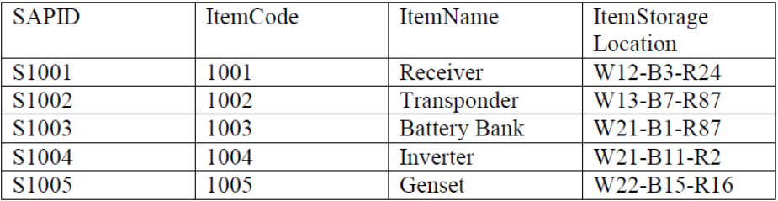  Table : Store  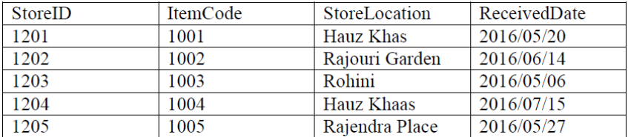  With reference to the above given tables, write commands in SQL for (i) and (ii) and output for (iii) below:  - To display the ItemCode,ItemName and ReceivedDate of all the items .  - To display SAPID,ItemName,ItemStorageLocation of all the items whose Received date is after 2nd May 2016.  - SELECT SAPID,ItemName,STOREID FROM SAP,Store WHERE SAP.ItemCode=Store.ItemCode AND StoreLocation = “Hauz Khas”  - What will be the degree and cardinality of the cartesian product formed while combining both the above given tables ‘SAP’ and ‘Store’ ?  - Sangeeta is not able to add a new record in the table ‘Store’ through the following query:  Insert into store values (1206,1006,’Karol Bagh’, ‘2016/07/25’);  Identify the error if there is any
    - Select SAP.ItemCode, ItemName, ReceivedDate
From SAP, Store
Where SAP.ItemCode=Store.ItemCode;
    - Select SapID, ItemName, storeLocation
From SAP, Store
Where SAP.ItemCode=Store.ItemCode and ReceivedDate>”2016-05-02”;
    - SAPID ItemName STOREID
S1001 Receiver 1201
S1004 Inverter 1204
    - The degree will be 8
The cardinality will be 25
    - She will not be able to insert the record as 1006 ItemCode is not there in the itemCode field in SAP table and since ItemCode in store table is a foreign key so it will refer its value from the itemcode field of SAP table.

Informatics Practices
My SQL Worksheet-10
(Transaction)
1. | Which command is used in MySql to make the changes in database permanent?
 | Commit
2. | Give one difference between ROLLBACK and COMMIT commands used in MySql.
Rollback reverses all the changes being done using insert, update or delete after starting the transaction.
Commit saves all the changes being done by Inssert, Update or delete after starting the transaction.
3. | A table named ‘GAMES’ has the following contents:  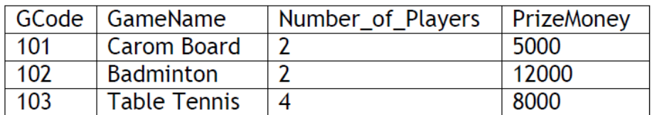  Write the output that will be displayed by statements (i) and (ii).  SELECT * FROM GAMES;  SET AUTOCOMMIT = 0;  INSERT INTO GAMES VALUES(105,'CHESS’,2,9000);  ROLLBACK;  SAVEPOINT S1;  SELECT * FROM GAMES; ------------ (i)  INSERT INTO GAMES VALUES(108,'LAWN TENNIS’,4,25000);  SAVEPOINT S2;  INSERT INTO GAMES VALUES(109,'CRICKET’,11,20000);  ROLLBACK TO S2;  SELECT * FROM ITEM; ------------ (ii)  i)  ii)
  GCode | GameName | Number_of_Players | PrizeMoney
  101 | Carom Board | 2 | 5000
  102 | Badminton | 2 | 12000
  103 | Table Tennis | 4 | 8000
  GCode | GameName | Number_of_Players | PrizeMoney
  101 | Carom Board | 2 | 5000
  102 | Badminton | 2 | 12000
  103 | Table Tennis | 4 | 8000
  108 | Lawn Tennis | 4 | 25000
4. | Consider the Stu table  The following SQL queries are executed on the above table  INSERT INTO Stu VALUES(5,'Gagan'); COMMIT;  UPDATE Stu SET name='Abhi' WHERE Rollno = 4  SAVEPOINT A;  INSERT INTO Stu VALUES(6,'Chris'); SAVEPOINT B;  INSERT INTO Stu VALUES(7,'Babita'); SAVEPOINT C;  ROLLBACK TO B;  What will be the output of the following SQL query now:  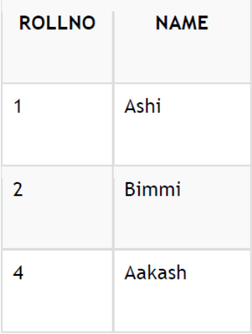SELECT * FROM Stu;
  RollNo | Name
  1 | Ashi
  2 | Bimmi
  4 | Abhi
  6 | Chris
5. | Given below is the ‘Stu’ table :  The following statements are entered :  SET AUTOCOMMIT = 0;  INSERT INTO Stu VALUES(5, ‘Rahul’); COMMIT;  UPDATE Stu set name=‘Rahuliya’ where Rno= 5; SAVEPOINT A;  INSERT INTO Stu VALUES(6, ‘Cristina’); SAVEPOINT B;  INSERT INTO Stu VALUES(7, ‘Fauzia’); SAVEPOINT C;  ROLLBACK TO B;  Now what will be the output of the following statement ?  SELECT * FROM Stu;
  RNO | NAME
  1 | Amit
  2 | Bhishm
  RNo | Name
  1 | Amit
  2 | Bhishm
  5 | Rahuliya
  6 | Cristina
6. | Geetanjali had created a table “Customer” in the database “Test”. Immediately after the successful creation of the database, she wrote the Rollback command to undo the creation of the table. Did she execute rollback successfully? Explain.
 | No, She did not execute the command successfully as rollback command only reverses the changes done using INSERT, UPDATE or DELETE.
7. | Given below is the ‘Department’ table :  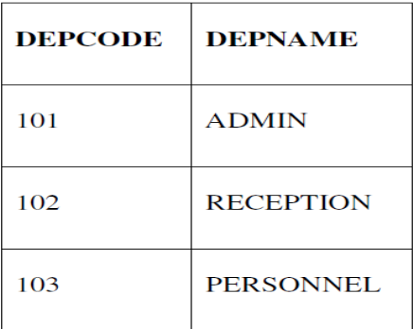 SET AUTOCOMMIT = 0;  UPDATE Department SET DEPNAME = ‘OFFICE’ WHERE DEPNAME =  ‘ADMIN’;  INSERT INTO Department VALUES (104, ‘HRD’);  UPDATE Department SET DEPNAME = ‘FRONT OFFICE’ WHERE  DEPNAME = ‘RECEPTION’;  COMMIT;  DELETE FROM Department WHERE DEPNAME = ‘FRONT OFFICE’;  ROLLBACK;  SELECT * FROM Department;  What will be the output of the above given SELECT statement ?
DepCode | DepName
101 | OFFICE
102 | FRONT OFFICE
103 | PERSONNEL
104 | HRD

